

Assignment 1:

Sharp Mail Order

Employee Sales bonus

Tom Tsiliopoulos

Georgian College

Table of Contents

Summary: 3

GUI Sketch: 3

Code Planning 4

Final Form Sample 6

# Summary:

This application is designed to calculate the amount of money an employee of Sharp Mail Order earned, based on the total sales of the company, given the sales of the store during the sale period, and the number of hours the employee worked during the period of that sale. The store was open for one hundred and sixty hours during the sale, as a result the user cannot enter an employee’s hours that exceed one hundred and sixty hours.

# GUI Sketch:

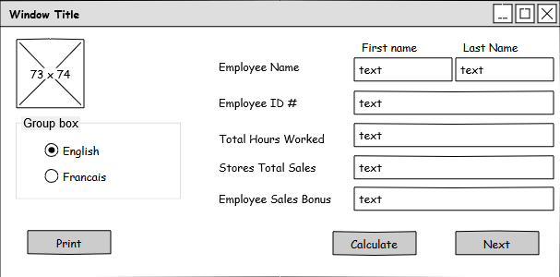

Input Employees name

Input store’s sales here

Input employees hours worked

Input store’s sales here

Output of Employee’s share of sales

Click to calculate the employee’s share of the sales

Click to go to the next employee

Click to send form to printer

Select language

# Code Planning

|  |  |
| --- | --- |
| form |  |
| firstName | Text input field to enter an employee’s first name |
| lastName | Text input field to enter an employee’s last name |
| employeeID | Text input field to enter an employee’s ID # |
| totalHours | Text input field to enter the total number of hours worked by the employee |
| totalSales | Text input field to enter the total sales of the store |
| salesBonus | Output field for total bonus employee has earned from the sale |
| errorBox | Outputs any errors to the user |

|  |  |
| --- | --- |
| errorBox | Properties |
| Size | 572, 26 |
| BorderStyle | FixedSingle |
| Enabled | False |
| Location | -4, 207 |

|  |  |
| --- | --- |
| employeeEarnings | Properties |
| BackColor | 53,53,53 |
| StartPosition | CenterScreen |
| Text | Employee Earnings |
| Size | 572, 266 |
| MaximizeBox | False |
| FormBorderStyle | FixedSingle |
|  |  |

|  |  |
| --- | --- |
| Functions |  |
| Form_Load | Loads form and sets focus on employee first name |
| englishButton_CheckedChanged | Convert all labels to english |
| frenchButton_CheckedChanged | Convert all labels to french |
| calculateButton_Click | Calculates the employee’s share of the stores sales |
| nextButton_Click | Clears all fields but the total sales field to allow input for next employee |
| printButton_Click | Send form to printer |
| clearErrorBox | Clears error box and hides it from user |
| validateData | Ensures that data is numeric |
| totalSales_Leave | Validated inputed data in the total sales field, and converts the numeric input in the total sales field to currency format |
| totalHours_Leave | Validate the data in the total hours field |
| convertFromCurrencyToNumeric | Performs conversion of total sales from currency to numeric |
| convertSalesToCurrency | Performs conversion of total sales from numeric to currency |
| Error | Handle error outputs |
| clearFields | Clear all fields |

# Final Form Sample

